**Lab Week 3**



Session: 2022 – 2026

**Submitted by:**

Muhammad Saad Akmal 2022-CS-148

**Submitted To:**

Sir Samyan

Department of Computer Science

**University of Engineering and Technology**

**Lahore Pakistan**

**Problem 1**

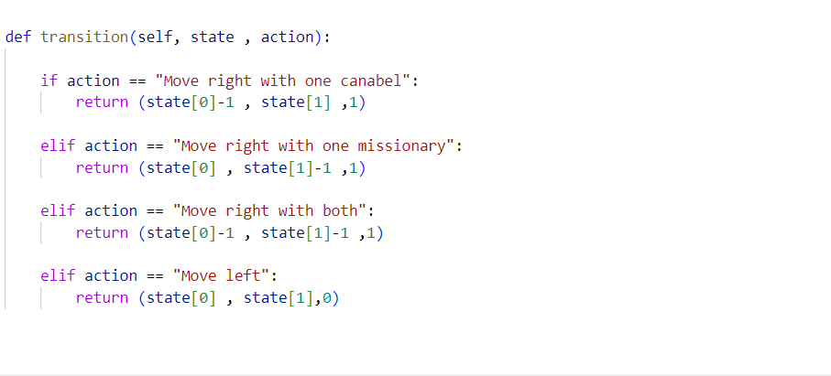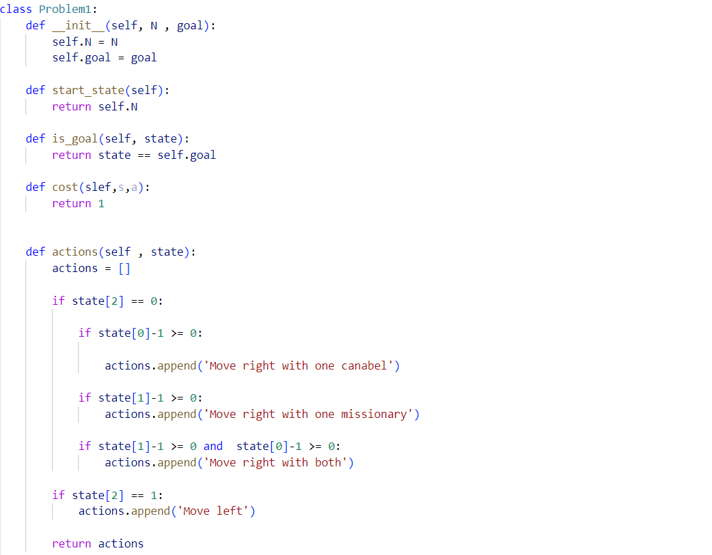

**Output:**

BFS result is ([(3, 3, 0), (2, 2, 1), (2, 2, 0), (1, 1, 1), (1, 1, 0), (0, 0, 1)], 5)

DFS result is ([(3, 3, 0), (2, 2, 1), (2, 2, 0), (1, 1, 1), (1, 1, 0), (0, 0, 1)], 5)

UCS result is ([(3, 3, 0), (2, 2, 1), (2, 2, 0), (1, 1, 1), (1, 1, 0), (0, 0, 1)], 5)

IDS result is ([(3, 3, 0), (2, 2, 1), (2, 2, 0), (1, 1, 1), (1, 1, 0), (0, 0, 1)], 5)

**Problem 2:**

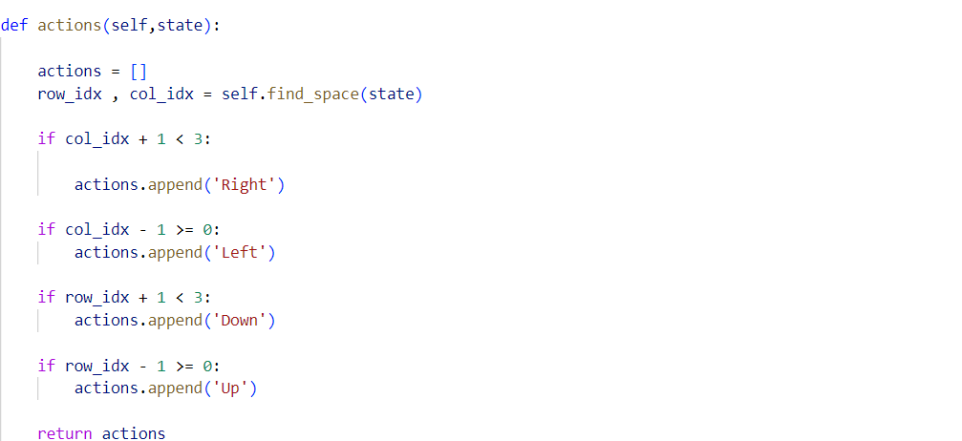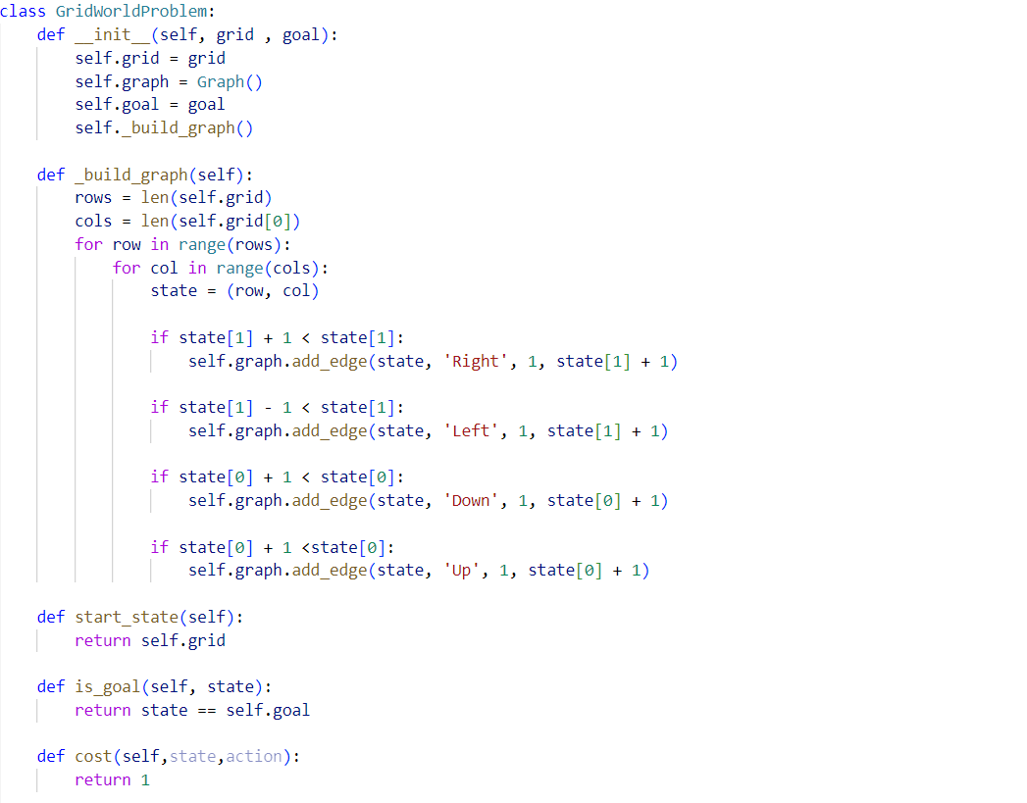

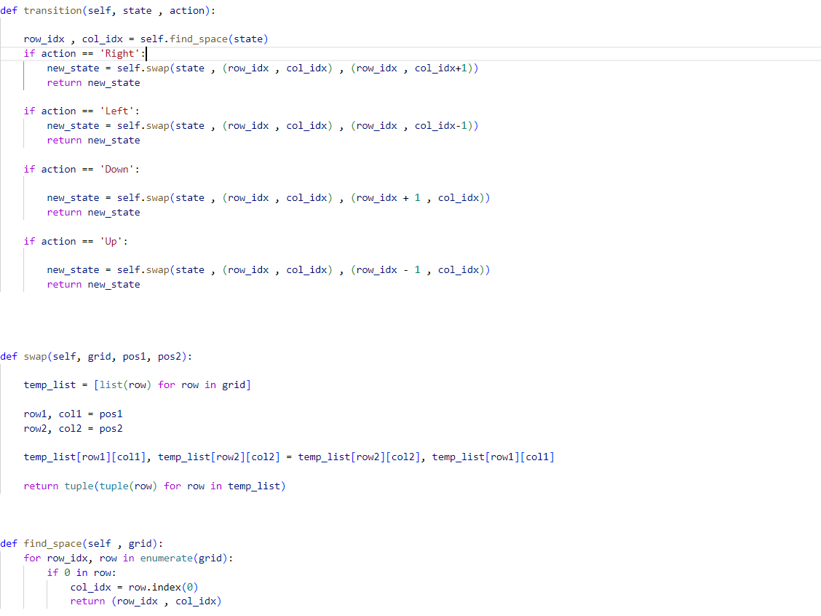

**Output:**

Initial state: ((1, 2, 3), (4, 0, 6), (7, 5, 8))

Final State**:**( (1, 2, 3), (4, 5, 6), (7, 8, 0))

BFS result is ([((1, 2, 3), (4, 0, 6), (7, 5, 8)), ((1, 2, 3), (4, 5, 6), (7, 0, 8)), ((1, 2, 3), (4, 5, 6), (7, 8, 0))], 2)

DFS result too large, Cost:320

UCS result is ([((1, 2, 3), (4, 0, 6), (7, 5, 8)), ((1, 2, 3), (4, 5, 6), (7, 0, 8)), ((1, 2, 3), (4, 5, 6), (7, 8, 0))], 2)

IDS result is ([((1, 2, 3), (4, 0, 6), (7, 5, 8)), ((1, 2, 3), (4, 5, 6), (7, 0, 8)), ((1, 2, 3), (4, 5, 6), (7, 8, 0))], 2)

**Problem 3:**

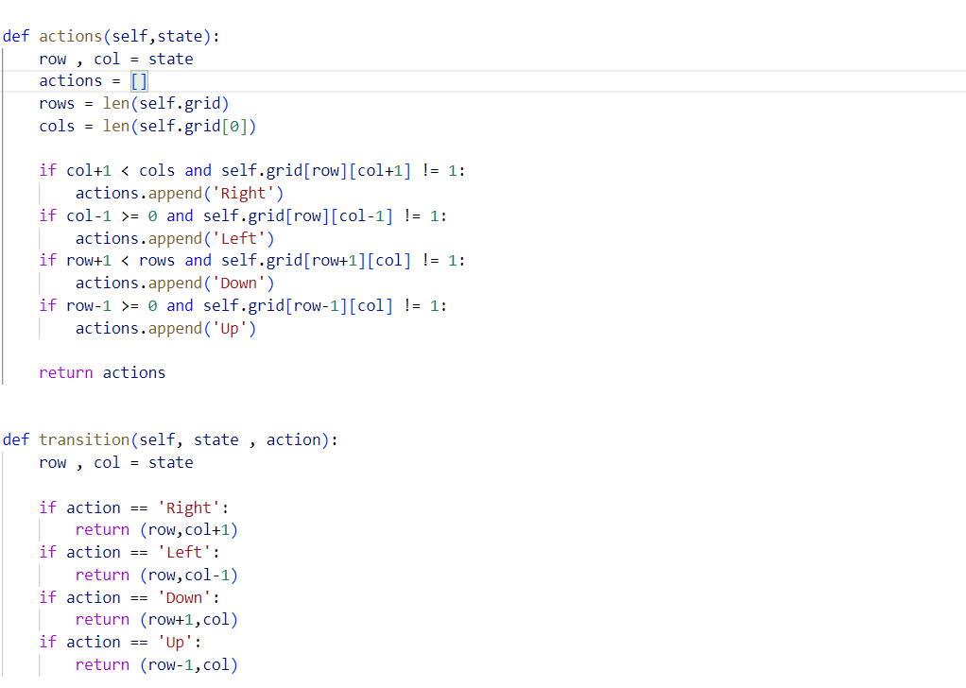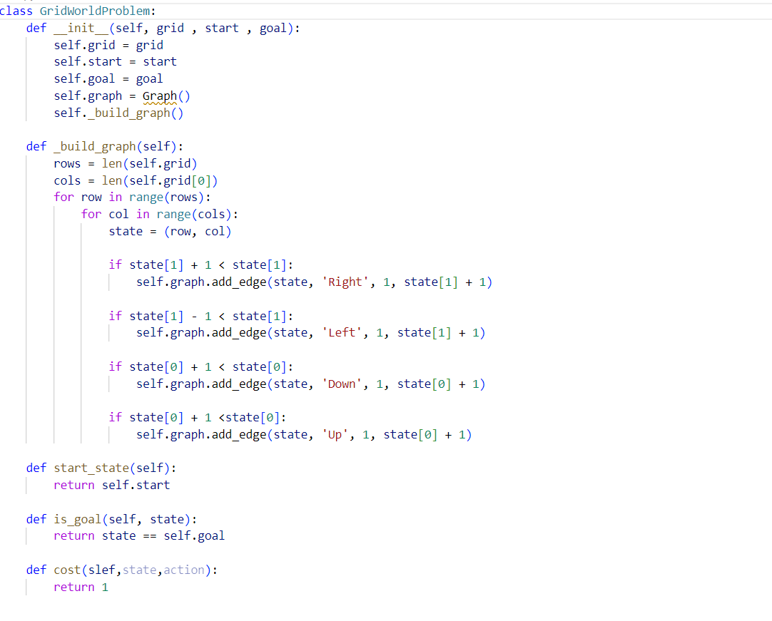

**Output:**

BFS result is ([(0, 0), (0, 1), (1, 1), (2, 1), (2, 2), (2, 3), (3, 3), (3, 4), (3, 5), (4, 5), (5, 5)], 10)

DFS result is ([(0, 0), (0, 1), (1, 1), (2, 1), (2, 0), (3, 0), (4, 0), (4, 1), (4, 2), (5, 2), (5, 3), (5, 4), (5, 5)], 12)

UCS result is ([(0, 0), (0, 1), (1, 1), (2, 1), (2, 2), (2, 3), (3, 3), (3, 4), (3, 5), (4, 5), (5, 5)], 10)

IDS result is ([(0, 0), (0, 1), (1, 1), (2, 1), (2, 2), (2, 3), (3, 3), (3, 4), (3, 5), (4, 5), (5, 5)], 10)

**Problem 4:**

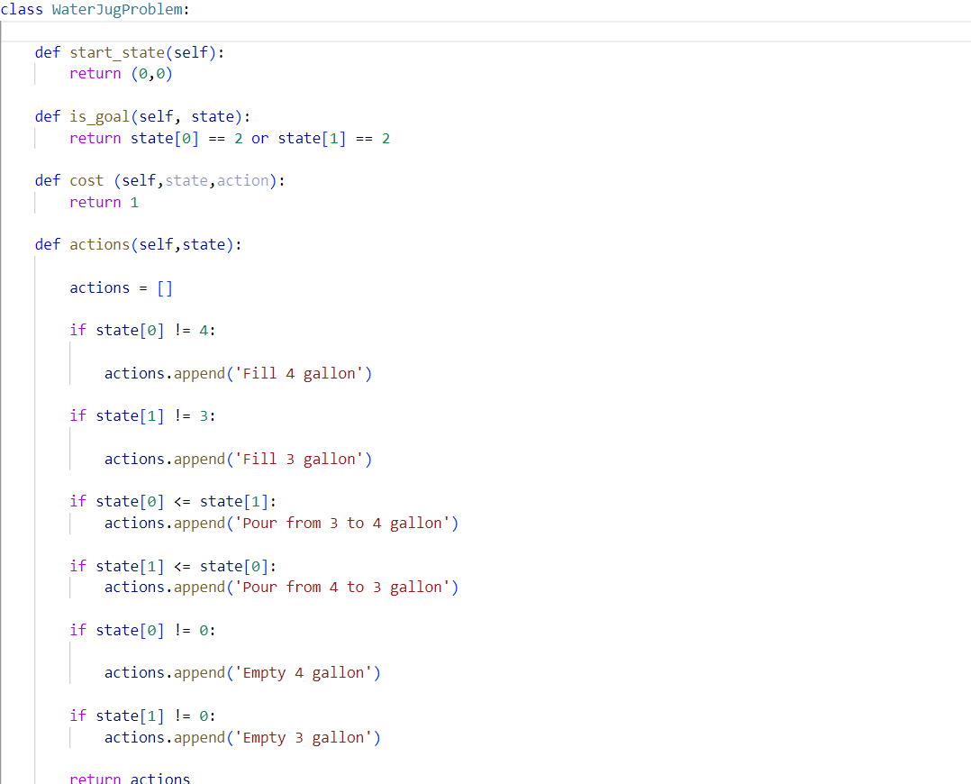

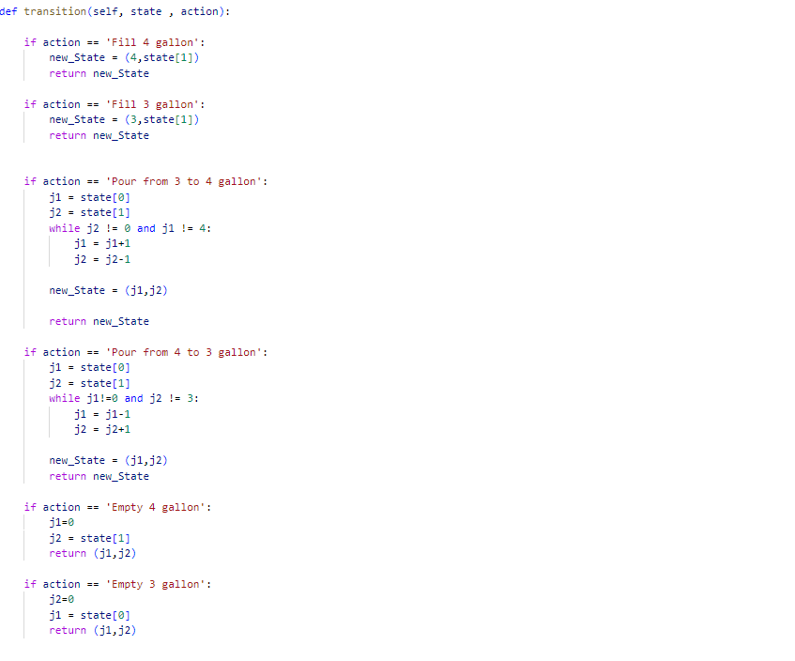

**Output:**

BFS result is ([(0, 0), (4, 0), (1, 3), (1, 0), (0, 1), (4, 1), (2, 3)], 6)

DFS result is ([(0, 0), (4, 0), (1, 3), (1, 0), (0, 1), (4, 1), (2, 3)], 6)

UCS result is ([(0, 0), (4, 0), (1, 3), (1, 0), (0, 1), (4, 1), (2, 3)], 6)

IDS result is ([(0, 0), (3, 0), (0, 3), (4, 3), (4, 0), (1, 3), (1, 0), (0, 1), (3, 1), (4, 1), (2, 3)], 9)

**Problem 5:**

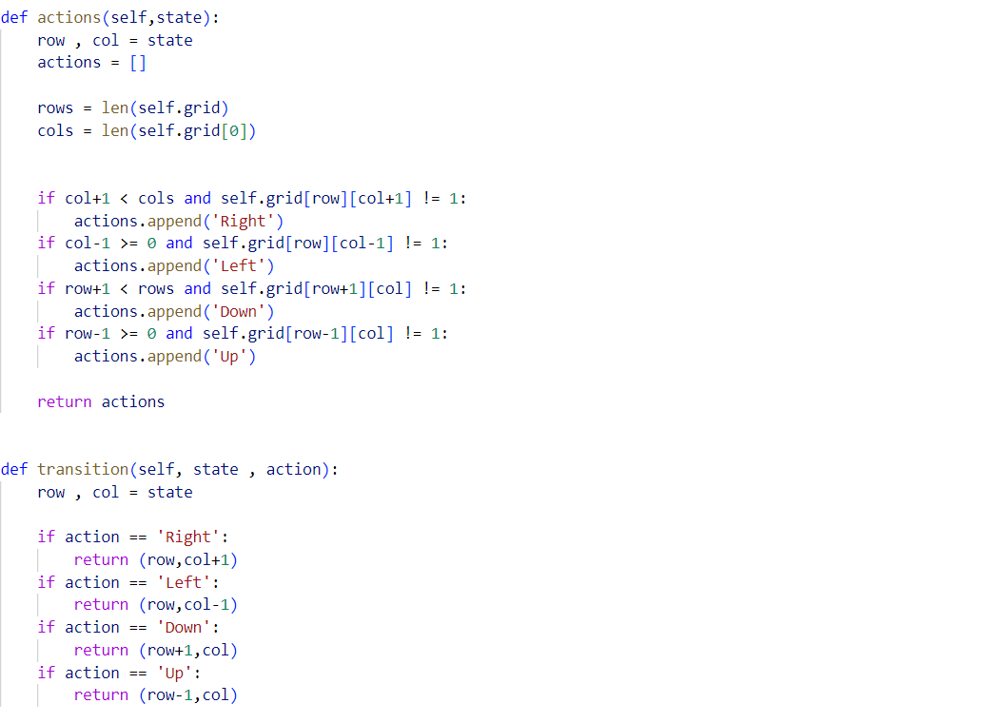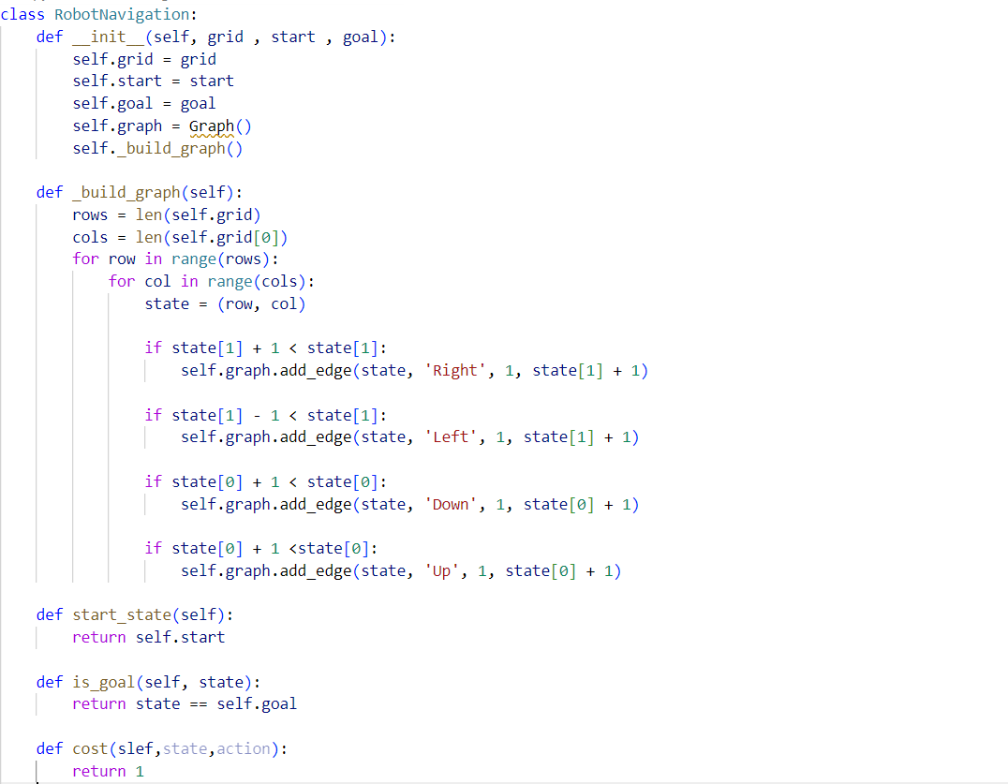

**Output:**

BFS result is ([(0, 0), (1, 0), (2, 0), (2, 1), (2, 2), (2, 3), (3, 3), (4, 3), (5, 3), (5, 4), (5, 5)], 10)

DFS result is ([(0, 0), (1, 0), (2, 0), (2, 1), (2, 2), (2, 3), (3, 3), (4, 3), (5, 3), (5, 4), (5, 5)], 10)

UCS result is ([(0, 0), (1, 0), (2, 0), (2, 1), (2, 2), (2, 3), (3, 3), (4, 3), (5, 3), (5, 4), (5, 5)], 10)

IDS result is ([(0, 0), (1, 0), (2, 0), (2, 1), (2, 2), (2, 3), (3, 3), (4, 3), (5, 3), (5, 4), (5, 5)], 10)